Math Circle Problem Set 10. Name:

Problem 10.1: There was a scavenger hunt in Hogwarts. Everyone had a great time, but we forgot what the teams were!

Name | Type | House | Group
Harry | Student | Gryffindor
Ron | Student | Gryffindor
Hermione | Student | Gryffindor
Hannah | Student | Hufflepuff
Susan | Student | Hufflepuff
Megan | Student | Hufflepuff
Morag | Student | Ravenclaw
Mandy | Student | Ravenclaw
Padma | Student | Ravenclaw
Draco | Student | Slytherin
Crabbe | Student | Slytherin
Goyle | Student | Slytherin
McGonagall | Professor | Gryffindor
Sprout | Professor | Hufflepuff
Flitwick | Professor | Ravenclaw
Snape | Professor | Slytherin

Here is what I remember about who was on which team:
- The teams each had 1 adult and 3 students.
- The teams each had one person from all four houses.
- Draco and Hermione complained about being on the same team.
- Crabbe said “Everyone else on my team has a name starting with M!”
- Mandy and Harry were on the same team.
- Padma, Hermione, and Hannah were on different teams.

Problem 10.1: You are stealing some plans from a secret base. The plans are behind a door secured by a 2-digit password. Here is the keypad:

1 | 2
3 | 4

Fortunately, the keypad doesn’t make you press “ENTER” to attempt a password. Whenever you put in a new digit, the door will open if you’ve just completed the password.

For example, if the password ends up being “34” and you enter “1234” the door will open. (It also would have opened if the password had been “12” or “23” because those passwords had appeared earlier in your sequence.)

Part A: You heard that the password doesn’t have a 4 in it. What is the shortest sequence you can find that contains all passwords involving a 1, 2, and/or 3?

Part B: Now the password might have a 4 in it. What is the shortest sequence you can find to make sure the door opens?
Problem 10.2: A ball starts at the lower-left corner of an M x N rectangular table and travels at a 45-degree angle. When it hits a wall, it reflects perfectly. The ball stops when it reaches any corner. Here is an example of the ball traveling on an 8 x 6 table:

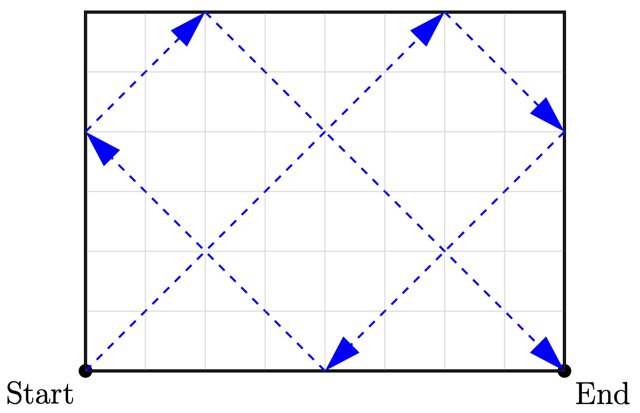

Using your graph paper, draw the paths of the following tables:
- 7 x 5
- 4 x 3
- 8 x 10

Problem 10.3: Compare the path you drew on the 4 x 3 table to the picture above of the 8 x 6 table. Describe what is happening.

Problem 10.4: What corner (upper right, upper left, lower right) will the ball end up in on a 4 x 5 table? (Refer to your drawing of the 8 x 10 table.)
Problem 10.5: Draw the path of a ball on 1 x 2, 2 x 3, 3 x 4, and 4 x 5 tables. What pattern do you see for where the ball ends up? Where do you think the ball would end up on a 99 x 100 table? Where would it end up on a 100 x 101 table?

Problem 10.6: Draw 1 x 1, 1 x 2, 1 x 3, ..., 1 x 7 tables. What is the pattern for where the ball ends up?

Problem 10.7: Draw 2 x 1, 2 x 3, 2 x 5, 2 x 7, 2 x 9 tables. What is the pattern for where the ball ends up?

